As an engineering intern at Textron Aviation, I was tasked with creating circuitry to ensure compatibility between a sensor mounted on a rudder pedal and the rest of the brake test article simulator, under the guidance of my mentor (Senior Engineering Specialist, Jonathan Kaufman). The sensor was variable between -15-volts and +15- volts, but the analog input pin on the Teensy 3.2 Arduino board was only tolerant to inputs between 0-volts and 3.3-volts. The Teensy was used to provide joystick readings to FlightGear, an open-source flight simulation software, which in turn, reflected the rudder pedal’s deflection within the software.

* 1. I drew a schematic using my circuitry knowledge learned in the classroom to bring the voltage within the acceptable range. I used 2 operational amplifiers to achieve this. The first operational amplifier was used to bring down the range of the voltage readings between -1.65-volts and +1.65-volts. The second operational amplifier offset this voltage range by +1.65 volts to bring the range between 0-volts and 3.3-volts **(Figure 8)**.

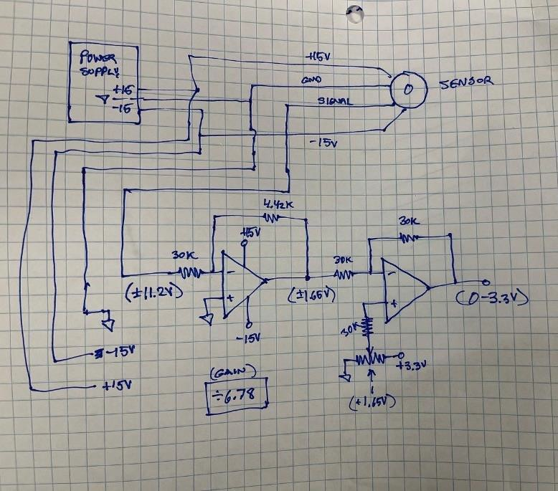

**Figure 8:** Schematic of Rudder Pedal Sensor Circuitry

* 1. As seen in the breadboarded version of the circuit, I used a placeholder potentiometer which also varied between -15 volts and +15 volts, rather than the actual sensor on the final rudder pedal apparatus **(Figure 9)**.

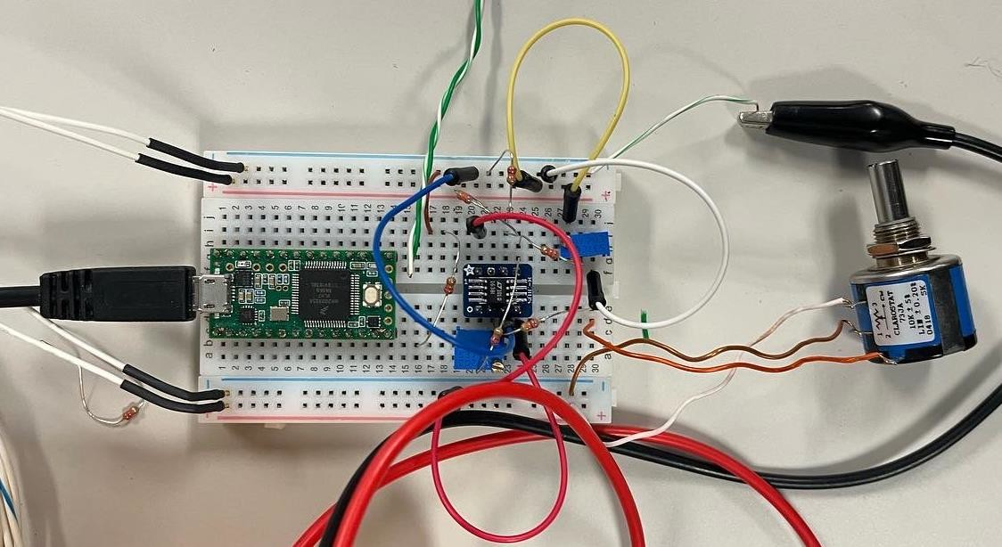

**Figure 9:** Breadboarded Rudder Pedal Sensor Circuitry

* 1. Finally (not pictured in Figure 9), I used a wire to create a connection between the output on my circuit and the analog input pin on the Teensy.
  2. I hooked up the Teensy, using a micro-USB cable, to the computer and coded a basic Arduino program which provided the accurate rudder pedal deflection readings as I turned the dial on the -15/+15-volt potentiometer.

This project was challenging, but with the support of my mentor, I was able to achieve my initial goal. I particularly enjoyed this project because it was one of the main instances where I was stretched to take my learning and understanding of concepts, outside of the classroom. I learned basic circuitry concepts in my AP Physics 2 class at school, so it was exciting to be able to apply them in the real world.